Create table of **salesorder** with following fields: Order Number(Unique key begins with 0),Client

number(FK),Order Date.

Create table **clientmaster** with following fields: clientno(PK), cname,city.

Create table **salesmaster** with following fields: salesmanno(PK),sname,city.

Add 5 rows of data in 3 tables

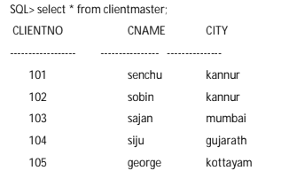

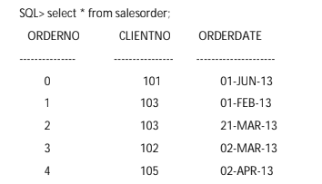

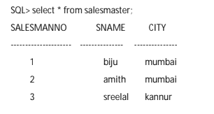

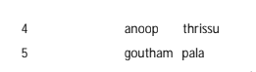

a)Retrieve all orders placed by a client named sajan.

b)Retrieve the names of all clients and salesman in the city of mumbai.

c)Retrieve the order number, cname, order date from client master and sales order table.